Assignment No : 5

Name :Kaveri Avinash Jarhad
Shunbhangi Balaji Khavle

Write a menu driven program to create set and dictionary

my_dict = {}
my_set = set()

def add_dict():
global my_dict
key = input("Enter the key: ")
value = input("Enter the value: ")
my_dict[key] = value # Adds or updates the key-value pair
return my_dict

def display_dict():
print("Dictionary is:", my_dict)
return my_dict

def search_dict():
key = input("Enter the key to be searched: ")
if key in my_dict:
print(f"It exists! Value: {my_dict[key]}")
else:
print("It does not exist")

def add_set():
global my_set
s = int(input("Enter the number: "))
my_set.add(s) # Sets use .add(), not .append()
return my_set

def display_set():
print("Set is:", my_set)
return my_set

def search_set():
i = int(input("Enter the member to be searched: "))
if i in my_set:
print("It exists")
else:
print("It does not exist")

while True:
print("\n=== Main Menu ===")
print("1. Add to Dictionary")
print("2. Add to Set")
print("3. Search the Dictionary")
print("4. Search the Set")
print("5. Exit")

try:
choice = int(input("Enter your choice: "))
except ValueError:
print("Please enter a valid number.")
continue

if choice == 1:
add_dict()
display_dict()
elif choice == 2:
add_set()
display_set()
elif choice == 3:
search_dict()
elif choice == 4:
search_set()
elif choice == 5:
print("Exiting program. Goodbye!")
break
else:
print("Invalid choice. Please try again.")

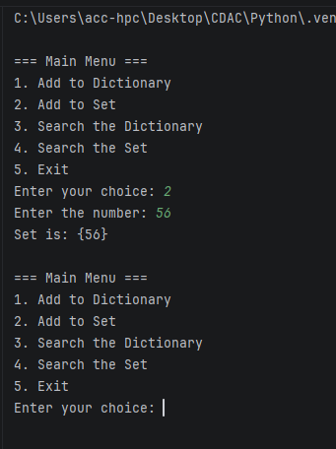

Write a program to count the number of characters and lines in a file
import os
file = open(r"C:\Users\acc-hpc\Downloads\data.txt","r+")
content = file.read()

char_count = len(content)
line_count = len(content.splitlines())

print("Total Characters:", char_count)
print("Total Lines:", line_count)

file.close()

